Multiple-choice section – choose the correct answer

Question 1 [6.1]

The angle corresponding to *q* is:

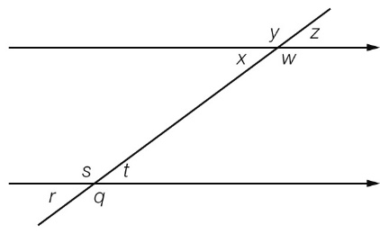

A *w* B *s* C *t* D *x*

Question 2 [6.1]

The supplementary angle of 105° is:

A 165° B 45° C 255° D 75°

Question 3 [6.1]

Which of these three values in the order of *p, u* and *v* are correct in the diagram?

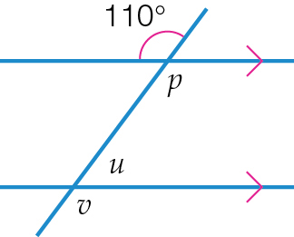

A 35°, 110°, 70° B 110°, 35°, 70° C 70°, 70°, 110° D 110°, 70°, 110°

Question 4 [6.2]

Which congruence test proves that the given pair of triangles is congruent?

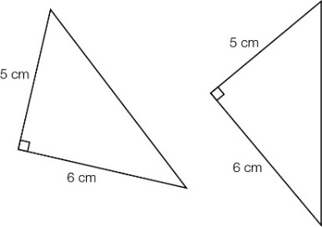

A RHS B SSS C SAS D ASA

Question 5 [6.4]

An equilateral triangle of side length 15 cm is reduced to become a triangle of side length 5 cm. The scale factor used is:

A  B 5 C  D 15

Question 6 [6.1,6.3]

What is the value of *x* in the following diagram?

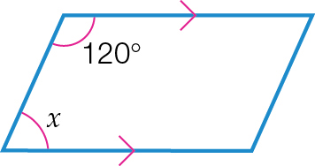

A 120° **B** 180° **C** 360° **D** 60°

Question 7 [6.3]

The sum of the interior angles of a hexagon is:

A 360° B 180° C 720° D 540°

Question 8 [6.5]

The scale factor of the pair of similar triangles is:

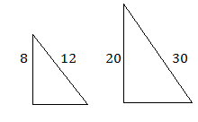

**A** **** **B** **** **C** **** **D** ****

Question 9 [6.3]

Find the value of angle *a* in this regular pentagon.

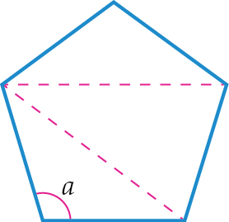

**A** 48° **B** 108° **C** 90° **D** 540°

Multiple-choice results: \_\_\_ / 9

Short answer section

Question 10 3 marks [6.1,6.2,6.5]

Use words from the list below to complete the following sentences.

congruent corresponding angles alternate angles similar co-interior angles solid

**(a)** Two triangles are \_\_\_\_\_\_\_\_\_\_\_\_\_\_\_\_\_\_\_\_\_ if they are the same shape and the same size.

**(b)** Triangles that are the same shape but not the same size are\_\_\_\_\_\_\_\_\_\_\_\_\_\_\_\_\_\_\_\_\_.

**(c)** \_\_\_\_\_\_\_\_\_\_\_\_\_\_\_\_\_\_\_\_\_ are found on the opposite sides of a transversal that crosses a pair of parallel lines.

Question 11 3 marks [6.1]

State the values of *a*, *b*, *c, d*, *e*, *f* and *g* for this pair of parallel lines and transversal.

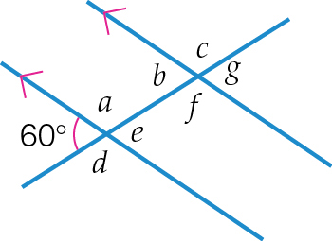

Question 12 6 marks [6.3]

Name each polygonandfind the values of the pronumerals for each.

**(a)**

**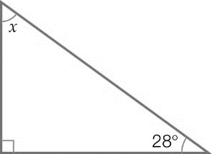**

**(b)**

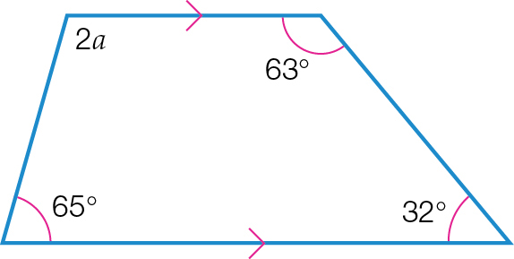

**(c)**

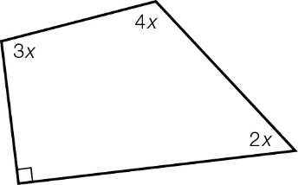

(*Note:* The sum of angles in a quadrilateral is 360°.)

3*x* + \_\_\_ + \_\_\_ + 90° = 360°

\_\_\_ *x* + 90 = 360°

­­­\_\_\_ *x* = ­\_\_\_

*x* = \_\_\_

**(d)**

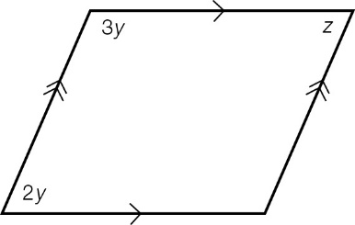

(*Note:* Co-interior angles in parallel lines add up to 180°.)

2*y* + \_\_\_\_ = 180°

\_\_\_\_\_*y* = 180°

*y* = \_\_\_\_

*z* = 2*y* (opposite angles of a parallelogram are equal)

*z* = \_\_\_\_\_

Question 13 3 marks [6.5]

Complete the working below to show that the pair of triangles are similar.

|  |  |
| --- | --- |
| ACPM9_PR_6_09tf_RR | ∠*ACB* = \_\_\_\_\_  ∠*EDF* = \_\_\_\_\_  In ∆*ABC* and ∆*DEF*  ∠*ABC* = ∠*\_\_\_\_\_\_* (both 120°)  ∠*ACB* = ∠*DFE* (both \_\_\_\_)  ∠*BAC =* ∠*EDF* (both \_\_\_\_)  ∴ ∆*ABC* ~ ∆*DEF* (\_\_\_\_\_) |

Question 14 2 marks [6.2]

Give reasons why the following pair of triangles are congruent.

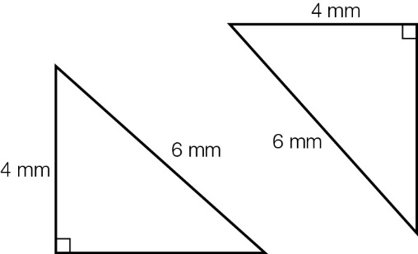

The hypotenuse in each triangle is \_\_\_\_\_ mm.

Each triangle has another side equal to \_\_\_\_ mm.

Each triangle has a \_\_\_\_\_\_\_\_\_ angle.

The triangles are shown to be congruent using the \_\_\_\_\_\_ test.

Question 15 2 marks [6.7]

Draw the net of the shape below, showing all necessary measurements.

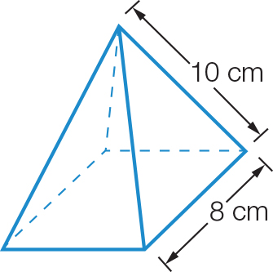

Question 16 2 marks [6.6]

Use the properties of similar triangles to find the distance across the river.

The triangles are similar because they each have a \_\_\_\_\_\_\_\_ angle and a pair of \_\_\_\_\_\_\_\_\_\_\_\_ opposite angles that are equal.

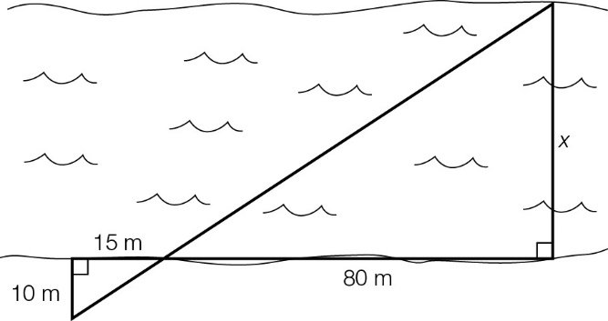



Question 17 3 marks [6.4]

The small pentagon has been enlarged to the large pentagon.

By measuring the sides of each pentagon, determine the scale factor.

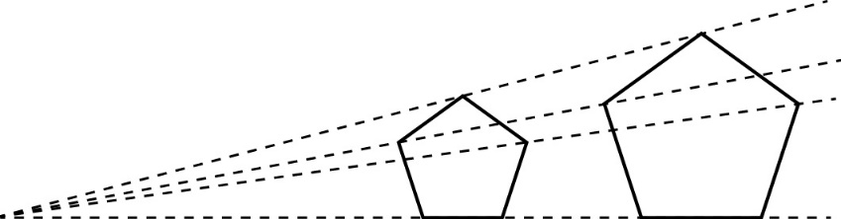

Length of side of small pentagon = \_\_\_\_\_\_

Length of side of large pentagon = \_\_\_\_\_\_

Scale factor = large side ÷ small side = \_\_\_\_ ÷ \_\_\_\_ = \_\_\_\_\_

Question 18 3 marks [6.1]

Find the value of the pronumerals. Give reasons for your answer.

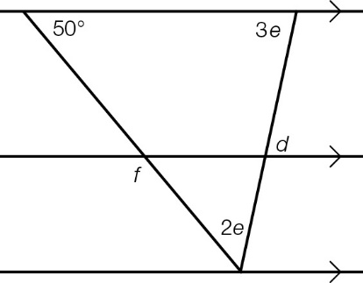

2*e* +*\_\_\_\_* + \_\_\_\_ = 180° (angle sum of triangle is 180°)

5*e* + \_\_\_\_ = 180°

5*e* = \_\_\_\_\_

*e* = \_\_\_\_\_ ÷ 5

*e* = \_\_\_\_\_

*d* = 3*e* (alternate angles in parallel lines are equal)

*d* = 3 × \_\_\_

= \_\_\_\_

*f* = \_\_\_\_

Question 19 3 marks [6.2]

Prove that ∆*DEH* ≡ ∆*GFH* and then find the value of *x*.

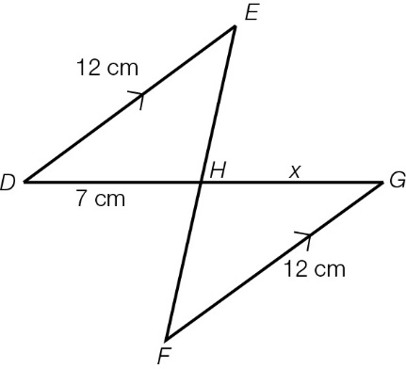

In ∆*DEH* and ∆*GFH*,

∠*DEH* = ∠*\_\_\_\_* (\_\_\_\_\_\_\_\_\_\_\_\_\_ angles, *DE* || *FG*)

∠*EHD* = ∠*\_\_\_\_* (\_\_\_\_\_\_\_\_\_\_\_\_\_ opposite angles)

*DE* = *FG* (both \_\_\_ cm, given)

∴ ∆*DEH* ≡ ∆*GFH* (\_\_\_\_\_\_)

∴ *x* = \_\_ (matching sides of congruent triangles)

Short answer results: \_\_\_ / 30

Extended answer section

Question 20 9 marks [6.3]

A special type of quadrilateral is shown below.

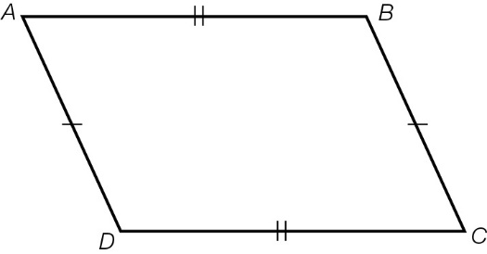

**(a)** What is the name of this quadrilateral?

**(b)** Write the pairs of equal sides.

**(c)** Write the pairs of equal angles.

**(d)** One diagonal is *AC*. Write the name of the other diagonal.

**(e)** Draw the diagonal *AC* on the figure. Write the names of the two triangles formed.

∆\_\_\_\_\_ and ∆\_\_\_\_\_\_

**(f)** Are the two triangles from part **(e)** congruent? Name the test used.

Question 21 8 marks [6.6]

Christy’s dad bounces a ball from his head height and Christy catches it at her head height, as the following diagram shows. If her dad is 2.1 m tall, how tall is Christy?

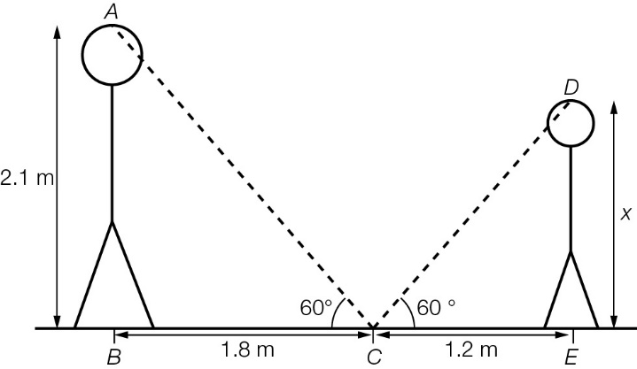

In ∆*ABC* and ∆*DEC*

∠*ABC* = ∠*\_\_\_\_* = 90° (given)

∠*ACB* = ∠*\_\_\_\_* (given)

∠*CAB =* ∠*\_\_\_\_* (angle sum in triangle)

∴ ∆*ABC* ~ ∆*DEC* (\_\_\_\_)

= \_\_\_ (matching sides of similar triangles are proportional)



Question 22 4 marks [6.6]

Mike is playing a game of snooker.

He is at point *A* and is aiming his ball at point *C*. Once the ball hits point *C*, it will reflect and go to point *D*.

Mike knows that the angle that a ball approaches the cushion is the same as the angle it bounces off the cushion. The path of the ball creates two similar triangles. Calculate the distance from point *E* to point *D*.

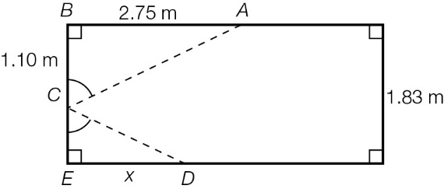

∆*ABC* is similar to ∆*DEC*.

*CE* = \_\_\_\_ m

****

****

Question 23 3 marks [6.7]

The formula below connects the number of edges (*E),* the number of faces (*F*) and the number of vertices (*V*) in any polyhedron.

Show working using the formula to prove the number of edges of a cube.

*F + V* – 2 = E

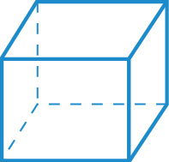

Question 24 3 marks [6.6]

A ladder is placed against the side of a house over the side of a 4 m fence. The foot of the ladder is 6 m from the fence and the fence is 8 m from the wall.

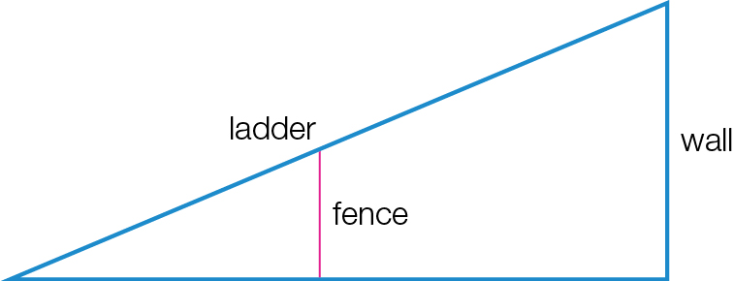

**(a)** Label all the measurements given.

**(b)** Determine the distance of the ladder along the wall. Show the similar triangles in your working.

Extended answer results: \_\_\_ / 27

TOTAL test results: \_\_\_ / 66